Blog Entry Form
Form and Guidelines for Blog Posts
on the SiC Website

Thank you for contributing to the SiC Blog!
SiC has always maintained an active online presence and one of the projects that has had the most success have been our blogs, where both team members and supporters of SiC can write about their experiences on a variety of topics, whether that is research results, an overview of a conference, information on cutting edge technologies or a guide on how to make sustainable decisions when you carry out your work. This form was created to give you, the author, guidelines on how to write your SiC blog. It gives you information on formatting, referencing, a permission form and asks for some contact details so we can keep in touch with you about your blog. Once you have completed this entry, please send it to sustainabilityinconservation@gmail.com.
Once your blog is edited, we will get back in touch with you to make sure that you are happy with any edits. Please do not hesitate to get in touch with us in case you have any questions! We look forward to reading your work!

About You
Name:
City, Country:
Email:
Current position:
Current employer/university:
Specialization/Areas of Expertise:

Blog Basics
- Aim for 500-1000 words
- We ask that all referencing is done in the Harvard style (see below for guide) – the most important thing is that all referencing is CONSISTENT throughout your text.
- It is best to avoid footnotes for the sake of readability, but endnotes may be included. Please place ’’[1]’’ in the text and list references at the end of the form
- No need to worry about the font as the text will be copied into the blog format
- Add images to the form (in the location you would like them to appear) AND separately as an attachment in the email. Images should be as large and high-quality as possible and in jpg or png format – no PDFs please!
- Please turn all tables into image format, in high quality. If you don’t know how to do this, please send the form at least three days prior to the deadline
- It is best to use your own images, but if not possible, always reference your sources (see below)
- Please indicate which image you would like to be the cover image for your blog
- Please indicate which image you would like to be used for social media
- Avoid long titles!

Referencing
We ask that all referencing is done in the Harvard style. We have listed examples below. For a comprehensive guide, you can also visit the following websites:
- https://www.citethisforme.com/harvard-referencing (last checked May 25, 2020)
- https://www.librarydevelopment.group.ac.uk/referencing/harvard.html (last checked May 25, 2020)
Images
Add a reference in a text box underneath the image and include the full source in the reference list
Source: LASTNAME, p. X.
Example:
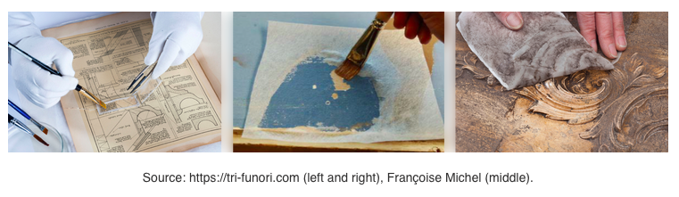
Source: https://trifunori.com (left and right), MICHEL, p. 5 (middle)
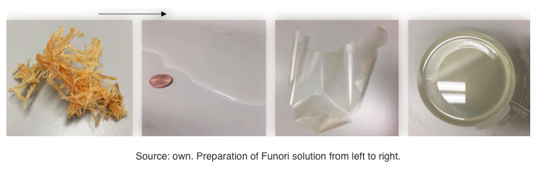
Source: own. Preparation of Funori from left to right.
Books
Author Surname, Initial(s)., (Year). Title. Edition (if not first edition). Place of Publication: Publisher.
Example:
Bryman, A., (2016). Social research methods. 5th ed. Oxford: Oxford University Press.
Articles
Author of article Surname, Initial(s)., (Year). Title of Article. Journal title. Volume in bold(Issue), page range.
Example:
Austin, T., (2012). Takers keepers, losers weepers: theft as customary play in southern Philippines. Journal of Folklore Research. 49(3), 263-284.

Articles from an online journal
Author of article Surname, Initial(s)., (Year). Title of article. Title of journal [online]. Volume in bold(Issue), page range. [Date viewed]. Available from: doi:
Example:
Dobson, H., (2006). Mister Sparkle meets the ‘Yakuza’: depictions of Japan in The Simpsons. Journal of Popular Culture [online]. 39(1), 44-68. [Viewed 5 October 2015). Available from: doi: 10.1111/j.1540-5931.2006.00203.x
Websites
Author of section Surname, Initial(s)/corporate author., (Year). Title of part [online[. Name of website. [Date viewed]. Available from: URL
Example:
Met Office., (2013). What do we mean by climate? [online]. Met Office. [Viewed 14 October 2015]. Available from: http://www.metoffice.gov.uk/climate-guide/climate

Entry Form
Details:
Blog description (max 320 characters):
Post URL (leave blank if no preference): blog/xxxxxx (please write in)
Tags (5 max):
Which image would you like to be used for promotion on social media? Please write the name of the image file:
Text:
Title:

Main text:
N. B. please place your images in the text here as you would like them to appear

References (please list the references you would like to be included with your text):

Permission
By submitting this article, you are agreeing to our publication terms and conditions.

☐Please check the box to agree to our publication terms and conditions. Articles cannot be accepted without this agreement.

Publication terms and conditions

The following publication terms and conditions apply to all articles, papers, documents, posts and other content (the “Content”) that you send to or submit with Stichting Ki Culture (registered with the Dutch trade register under number 76373878), acting as Sustainability in Conservation (“SiC”).

When submitting Content:

- you grant SiC (including its its successors, representatives, subsidiaries and assigns) a royalty-free, exclusive, worldwide, sublicensable, transferable and perpetual right and license to use, modify, amend, copy, publish, (re)print, share, distribute, spread and process such Content, in whatever language, in whatever form. SiC has the right to create derivative works based on the Content. SiC shall own all copyrights and intellectual property rights in such derivative works.

- you warrant that you are the sole author of the Content and that you hold all intellectual property rights, including copyrights, on the Content, and that the Content is not infringing any third parties’ intellectual property rights. In the event of breach of the foregoing, you will fully indemnify and hold harmless SiC against any and all damages (including reasonable costs for legal representation) resulting from any claim brought by a third party to SiC in connection with the Content.

