Example of a page from the gel’s cookbook, indicating why we need certain kinds of information.

AGAR

Definition
Another polymeric gel that has been used to clean paintings is agar. Richard Wolbers introduced agar to the field of art conservation through one of his workshops in 2003, and his research was then corroborated by Paolo Cremonesi and his team with their Cesmar 7 project. Subsequent literature highlights the easy application, superb efficacy, and non-toxicity of this polysaccharide gel. In the last decade, agar has been used extensively to treat artworks of varying kinds. The structure, properties and gelling mechanism of agar have been thoroughly described in many articles and books, so we will analyze and describe them very briefly here.

Definition: Agar or agar-agar gel is a physical gel composed of biopolymers. It is easily soluble in hot water, stable in alkaline and acidic conditions, and when not mixed with other substances it is a stable, non-toxic and environmentally friendly material.

Origin and industrial family: Agar is a natural vegetable gelatin counterpart composed mainly of an agarose and agaropectin mixture. Agarose is a non-ionic gelling agent, and agaropectin is the non-gelling, acidic and more structurally complex fraction of the polymer. Agar comes from red algae and from a type of seaweed. Different varieties of agar are commercially available. Ranging from laboratory to food additive grades, they have been tested for different purposes and all perform in a very similar way. In this study, we will be referencing an Agar purified for microbiology by Sigma - Aldrich 05040 agar. Its gelling temperature is 39 'C, as it is purified and will become a more transparent gel.
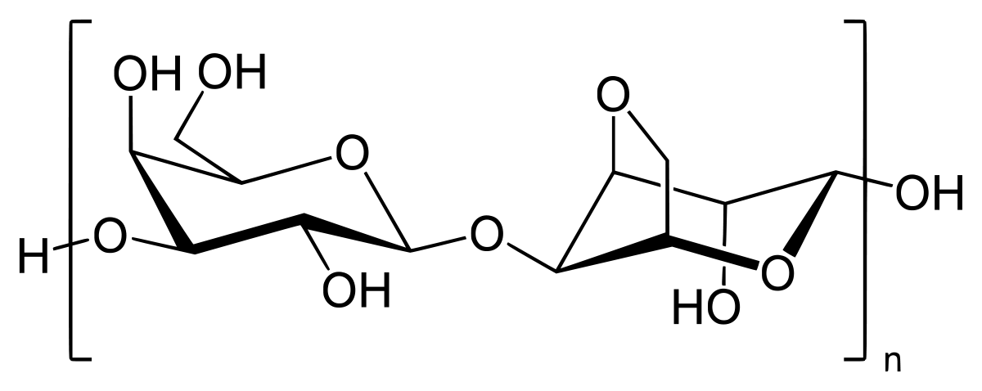
Fig. 14- Agarose

Gel’s manufacture/preparation: Agar is extracted from hot mucilage of algae and is then dried and milled. We can buy it in the form of a yellowish powder. It is prepared by adding the polymer to the solution to be gelled (2-5g to 100mL solution), then stirring and heating it (starting around 33-37 ºC and going to ~85ºC) until the polymers are assembled in a homogeneous system. The gelation occurs when the mixture is slowly cooled down to room temperature. Water molecules bind inside the helices of agarose and stabilize the material, creating a strong gel without losing any water. Agarose begins to form a gel in very low concentrations (0.2%).

Gel’s manufacture/extraction: Typically, agar is sold commercially as a powder and is then later mixed with water to obtain a gelatin. A short and simplified description of powdered agar-agar extraction is as follows: 1 - seaweed is washed to remove foreign matter; 2 - seaweed is soaked in heated water for several hours in order to dissolve the agar; 3 - the resulting mixture is filtered to remove the residual seaweed before being cooled to form a gel that contains about 1 percent agar; 4 - the gel is broken into pieces and sometimes washed to remove soluble salts, and, if necessary, it can be treated with bleach to reduce the color; 5 - the water is removed from the gel by varying methods; 6 - the product is then milled to a suitable and uniform particle size.

Physico-chemical properties and characterizations: Agar forms a hydrophilic and thermoreversible semi-rigid hydrogel after preparation. White and semi-translucent, it is insoluble at room temperature and melts at a high temperature (~85° C). It combines very limited adhesion to surfaces with high retention of water, and according to several tests it leaves no residual gelling material on the surface of artwork after it is used for cleaning. The main limitation of agar gel is the fact that it is rigid and, as in the case of Nanorestore Gel, it can only be applied to a surface that is almost completely flat. According to Cremonesi, agar gel is one of the safest ways to introduce water to a water-sensitive layer. The action of the gel can be further controlled with buffer solutions (its pH can range from 2-14), and agar acts as a molecular sponge.

Advantages summary:
- Easily removable – minimal mechanical stress
- High retention of water
- No gel residues
- Capacity of swell in buffer solutions
- Natural - good for the environment

Function
Gel is used for different purposes when controlled water is needed for cleaning. In theory it will swell the material that is to be removed, which is then cleared away mechanically. It can be used with normal or demineralized water, or a buffer solution.
- Glue removal: In a rigid or fluid form. The gel will swell the glue, after which removal with scalpel is normally required. No need for rinsing.
- Paper removal: In a rigid form. Place the gel over the material to be removed for a few minutes, and the paper will be easy to remove. Only use where there is natural or water-soluble glue.
- Surface Cleaning: When the surface of the art being conserved is water-sensitive, but water is required in the cleaning process (as in the case of acrylics or gilding), agar seems to be an excellent way to cleanse the object. It can be used in a fluid or rigid form. Agar will swell the dirt, which can then be removed with a sponge.

Preparation
This recipe was tested and used to clean acrylic paintings in Bianca Gonçalves’ thesis research on less toxic approaches to the cleaning of paintings, completed in 2018. The goal of the study was to make gels with a specific conductivity and pH for the cleaning of acrylic paintings. The same recipe can be used for any kind of cleaning.
MATERIALS | BEFORE START
- Compact Conductivity Meter LAQUA twin  - Compact pH meter LAQUA twin  - Demineralized water  - Buffer solution (in this case pH6/ 6000mS)  - Plastic recipient in PP to store the Agar  - Silicone forms for the agar gels  - Agar (in this case Sigma Aldrich Purified 05039-50G)  - Microwave/magnetic stirrer with hot plate  - Beaker and glass stick | 1- Calibrate the pH meter. For the pH measurement, demineralized water must come in contact with the electrode. Never touch the sensor with anything – VERY FRAGILE  2- Calibrate conductivity meter - For the measurement, the electrode must be dry (any amount of water can change the results)  3- Verify the temperature, conductivity, and pH of the demineralized water before starting

PREPARATION:
In a microwave:
- In 100mL of water (or buffer solution) mix 4g (4%) of agar inside a glass beaker. Stir well.
- Heat the solution to boiling in a microwave (less than 1 min should be enough). Stop the microwave to stir occasionally. Do not let water from boil out of the container. The agar will be ready when all of it is mixed into the water solution and no more grains are visible. The solution must be viscous.
- Pour solution into silicone forms or a flat container and allow it to cool down before putting it in the fridge to preserve. It will jellify very quickly.
In a magnetic stirrer:
- In 100mL of buffer solution mix 4g (4%) of agar inside a glass beaker. Stir well.
- Put the magnetic bar inside the mixture and combine in the magnetic stirrer. Set the hot plate to a minimum of 90ºC. Let the solution mix for several minutes. The agar is ready when all of it is mixed into the water solution and no more grains are visible. The solution must be viscous.
- Pour solution into silicone forms or a flat container and allow it to cool down before putting it in the fridge to preserve. It will jellify very quickly.
- Verify conductivity and pH before using the gel.

OBS- This process is easier and faster in a microwave. Make sure the microwave is cleaned before using it. The agar in this recipe is a mixture intended for use in microbiology cultures, so it is propitious to the growth of microorganisms. If we take care, it can last for months. However, if we want to be sure of its longevity an antifungal can be added, in which case rinsing may be necessary. We can load agar by other means; as in the case of Nanorestore gels, we can submerge it (in a gel form) in the buffer solution for some hours. This allows us to use other products that cannot be heated, especially at 90ºC.

This team has continued to study the use of agar in conservation, and their findings are published in two "Cuadernos" (Centro per lo Studio dei materiali per ii restauro). More information in http://cesmar7.org/
Sansonetti et al., “A Cleaning Method Based on the Use of Agar Gels: New Tests and Perspectives”; Scott, “The Use of Agar as a Solvent Gel in Objects Conservation”; Campani et al., L’uso Di Agarosio e Agar per La Preparazione Di ‘“Gel Rigidi”’; Chi, Chang, and Hong, “Agar Degradation by Microorganisms and Agar-Degrading Enzymes”; Galatas and Armisen, “Chapter 1 - Production, Properties and Uses of Agar”; Barbisan and Sophie Barbisan, “Le Fusain à l’œuvre : Étude et Conservation-Restauration Du Dessin de Présentation de l’Allégorie de Lyon (1861) Par Louis Janmot (Lyon, Musée Des Beaux-Arts). Mise Au Point d’une Méthode de Nettoyage Locale Des Auréoles à l’aide de Gels Rigides - Partie .”
Djabourov, “Gelation—A Review,” 137.
Agarose is a linear polymer made up of agarobiose (a disaccharide produced by D-galactose and 3,6-anhydro-L-galactopyranose). Agaropectin is a heterogeneous, complex mixture of smaller sulfated polysaccharide molecules (3% to 10% sulfate), composed of agarose that has varying percentages of sulphate and pyruvate ionizable functional groups. Baglioni and Chelazzi, Nanoscience for the Conservation of Works of Art, 287.
Cremonesi and Casali, “Thermo-Reversible Rigid Agar Hydrogels: Their Properties and Action in Cleaning,” 19.
A4675 agar type E, gelling temperature 26-28 "C: Sigma-Aldrich Co, St. LouisMO, http://www.sigmaaldrich.com
Baglioni and Chelazzi, Nanoscience for the Conservation of Works of Art; Impacto et al., “Rigid Gels and Enzyme Cleaning”; Scott, “The Use of Agar as a Solvent Gel in Objects Conservation.”
McHugh, A Guide to the Seaweed Industry ISSN, 17.
Bertasa et al., “A Study of Commercial Agar Gels as Cleaning Materials,” 11.
Cremonesi and Casali, “Thermo-Reversible Rigid Agar Hydrogels: Their Properties and Action in Cleaning.”
Paolo Cremonesi has been studying the application of the gel when it is still in its fluid state, but since we are applying it to a flat surface (painting) in this thesis, this research is not applicable. Ibid., 20.
Cremonesi and Casali, 21.
Scott, “The Use of Agar as a Solvent Gel in Objects Conservation.”

